**NETWORKING 1 – WEEK 3 – ACTIVITY 1**

Supply what is asking in the following statements. Attach or put a screenshot for each number to support your answers (if applicable).

As said, Bluetooth technology is one of the examples of technologies use in Personal Area Network.

1. For your activity, using two android phones with different specification (one low-end and the other one is high end if possible), determine and give how far can your Bluetooth connect or its longest range in meters or feet.

*CLOSE – 2 minutes and 10 seconds

*1 METER – 2 minutes and 15 secconds

*5 METER – 2 minutes and 30 seonds

*7 METER – 1 minute and 30 seconds

*10 METER - Unsuccesful

1. Make a documentation by taking two to five pictures of you and the other end device.

1 METER

CLOSE

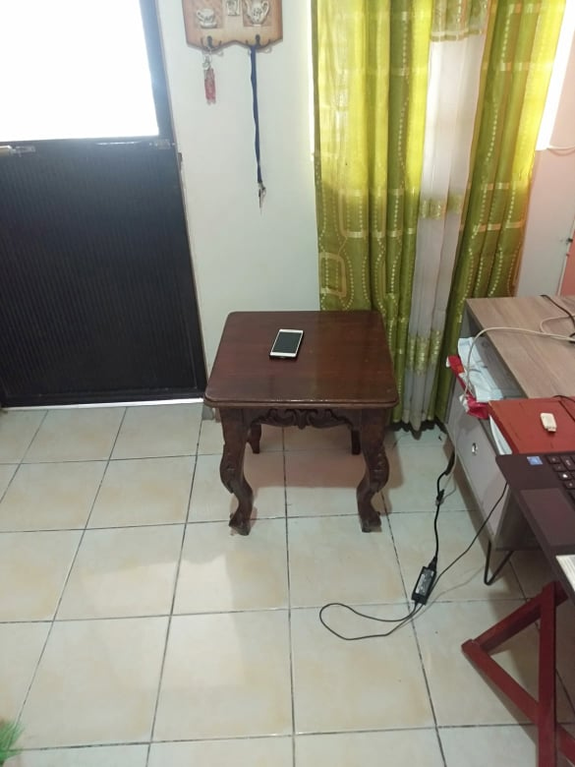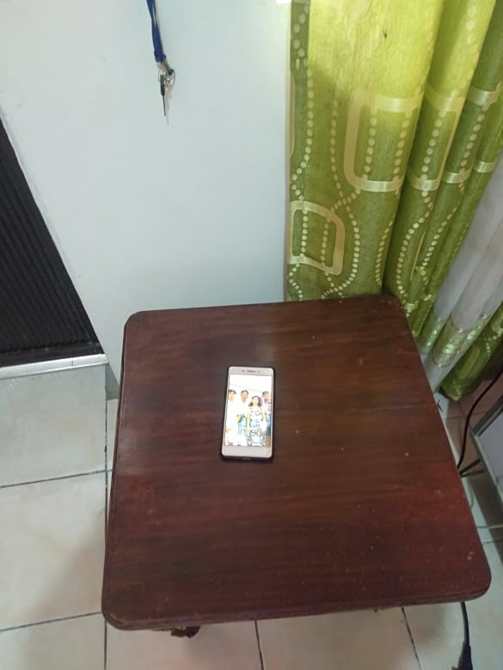

7 METER

5 METER

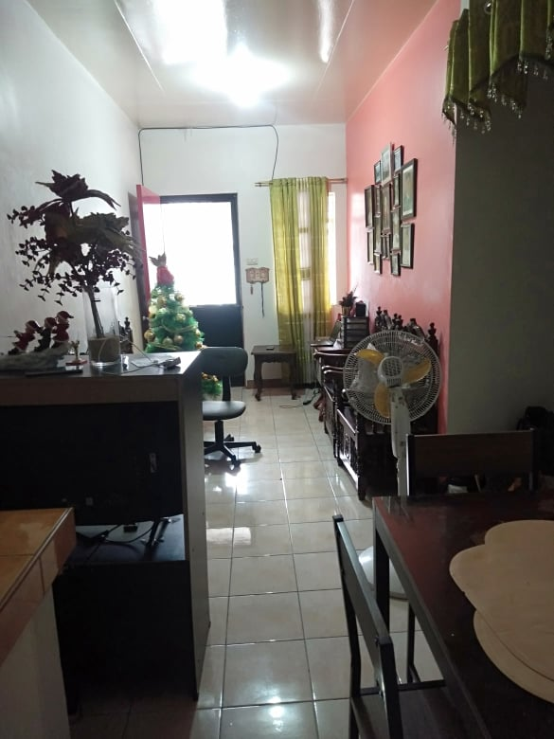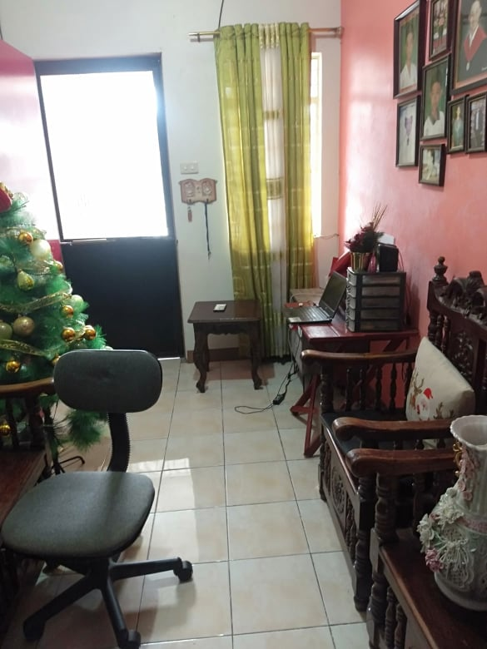



10 METER

1. Using personal android phone, create a screenshot of your complete Bluetooth device properties/information.

